Console Cable

🖧 What Is a Console Cable?
# Source: Chatgpt (GPT‑5 Mini) at [12/18/2025]
A Console Cable is a special cable used to connect a computer (usually via USB or serial port) to the console port of a networking device (like a router or switch) for initial setup, configuration, or troubleshooting — usually via a command-line interface (CLI).

Console Cable photo
# Source: Windows Screenshots (using Lightshot Program) at [12/18/2025]
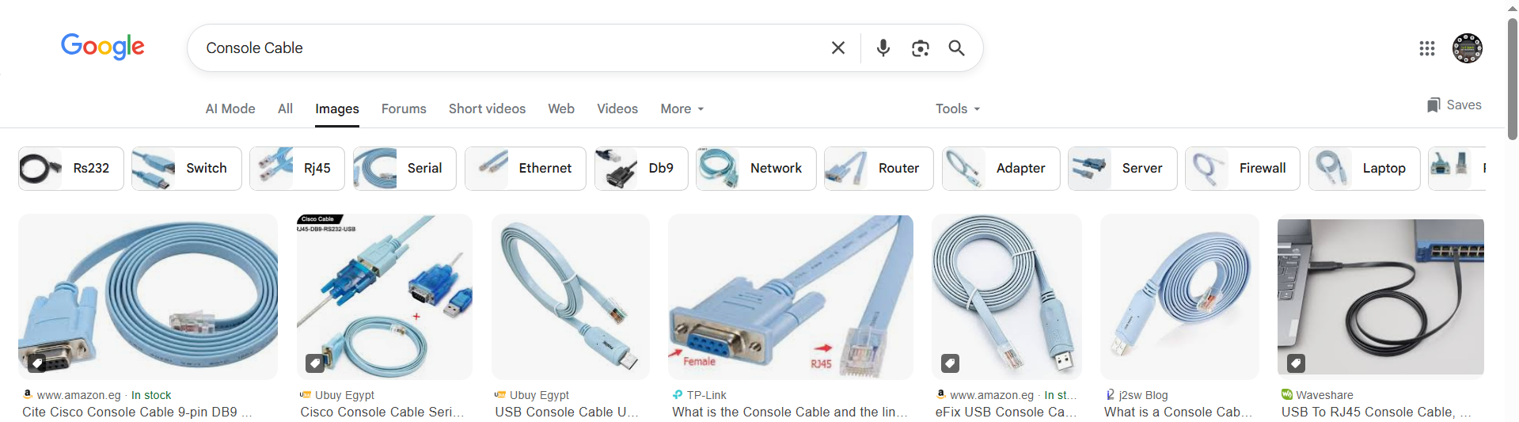

📦 Belongs to:
# Source: Chatgpt (GPT‑5 Mini) at [12/18/2025]
✅ Types of Network Cables
Specifically used for management/configuration, not data transfer between devices.

🧠 Purpose
# Source: Chatgpt (GPT‑5 Mini) at [12/18/2025]
A console cable allows direct, local access to a network device’s control interface when no network is available — especially during the first setup or recovery situations.

🧾 Common Types of Console Cables
# Source: Chatgpt (GPT‑5 Mini) at [12/18/2025]
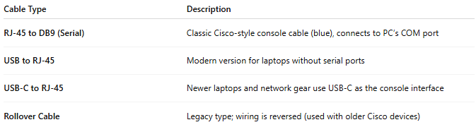

Cable Type | Description
RJ-45 to DB9 (Serial) | Classic Cisco-style console cable (blue), connects to PC’s COM port
USB to RJ-45 | Modern version for laptops without serial ports
USB-C to RJ-45 | Newer laptops and network gear use USB-C as the console interface
Rollover Cable | Legacy type; wiring is reversed (used with older Cisco devices)

🔧 Use Case Example
# Source: Chatgpt (GPT‑5 Mini) at [12/18/2025]
- Plug the RJ-45 end into the console port of a switch/router.
- Plug the USB/Serial end into your laptop.
- Open a terminal emulator (e.g., PuTTY, Tera Term, SecureCRT).
- Configure device using CLI (Command-Line Interface).

✅ Advantages
# Source: Chatgpt (GPT‑5 Mini) at [12/18/2025]
- 🛠️ Essential for initial configuration
- 🔧 Bypasses the network — works even if the device has no IP
- 💻 Works on bootloader or recovery level

❌ Disadvantages
# Source: Chatgpt (GPT‑5 Mini) at [12/18/2025]
- 🔌 Direct physical access required to the device
- ⚙️ Requires special software (and possibly drivers)
- 🧩 Not used for normal data traffic

📌 Summary
# Source: Chatgpt (GPT‑5 Mini) at [12/18/2025]
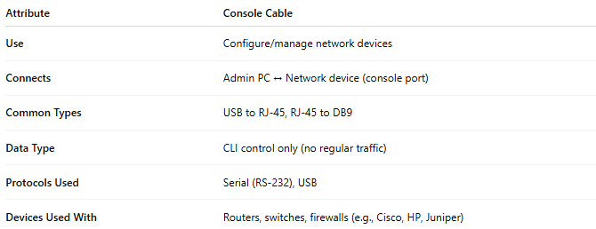

Attribute | Console Cable
Use | Configure/manage network devices
Connects | Admin PC ↔ Network device (console port)
Common Types | USB to RJ-45, RJ-45 to DB9
Data Type | CLI control only (no regular traffic)
Protocols Used | Serial (RS-232), USB
Devices Used With | Routers, switches, firewalls (e.g., Cisco, HP, Juniper)

